Designing a Healthier Drinks Fridge

Stocking your front facing fridges with healthy drinks at eye-level helps customers to see and choose the healthier options.
Win with water

You play an important role in encouraging and enabling players, families, and spectators to hydrate with water before, during and after exercise. Providing and promoting water over sugary drinks will allow you to support the health and wellbeing of your clubs’ and venue patrons.

When it comes to hydration and sport, water is the best choice for players, families, and spectators so be sure to display this prominently.

How to stock a healthier fridge
Follow this guide when stocking front facing fridges, where customers are either selecting options from the fridge themselves or can see the fridge when purchasing items.
- Fill the top half of fridges with healthier drink options such as,
  - plain, still or sparkling water,
  - flavoured waters with no added sugar, and
  - reduced fat plain or flavoured milk drinks.
Research shows that placing water at eye-level is one of the simplest yet most effective changes you can make.

- Position other drinks in the second or third last row from the bottom, such as,
  - full fat milk-based drinks,
  - 99–100% fruit juice, and
  - artificially sweetened or low sugar sports or soft drinks.
- Place drinks like full sugar soft drinks, iced tea and sport drinks in the lowest rows or opt to keep them on out of sight by removing them from any front facing fridges.
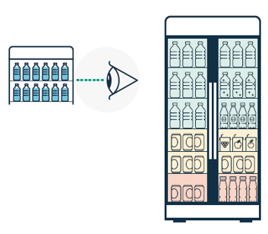

Find a plan-o-gram template on the next page.

Boost healthy options further
Look at other point of sale and display areas in the kiosk or canteen and place the healthy options at eye-level and in front of less healthy options.
Providing and promoting healthier options over less healthy options will allow you to support the health and wellbeing of your clubs’ patrons.
For more on A Better Choice for Sport and Recreation in Queensland, visit hw.qld.gov.au/a-better-choice/

Fridge plan-o-gram
Use the plan-o-gram template below to document the products you will display in your front facing fridges, to guide staff and/or volunteers when stocking the fridge/s.

Instructions: Stock the fridge with the products as specified in the table below.
X | X
X | X
X | X
X | X
X | X
X | X

