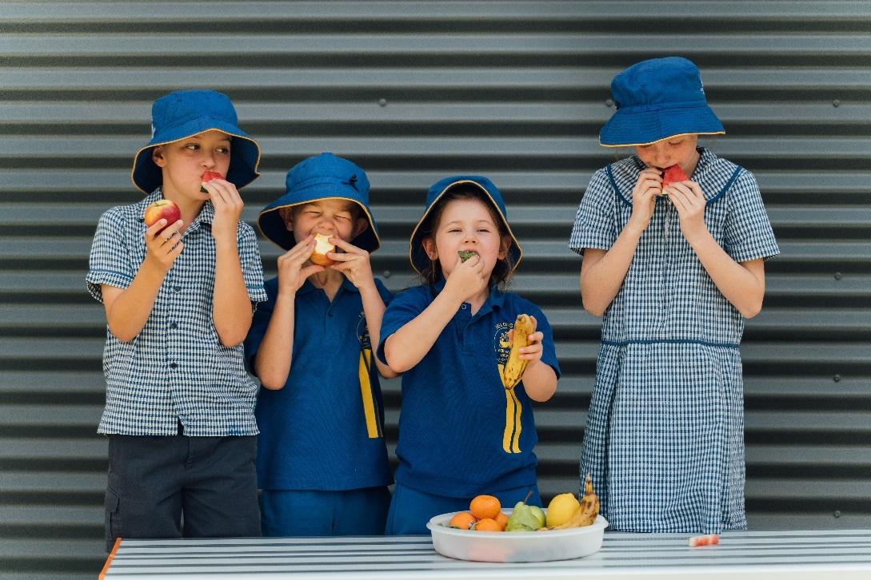

Connecting with families, parents and carers is an important activity for your school, to support teaching and learning as well as helping boost students’ growth and development so they become healthy adults.
As part of Health and Wellbeing Queensland’s Pick of the Crop program, this pack of 12 sample newsletter articles has been developed to help you communicate with your school community around healthy eating, using evidence-based information and advice. You may wish to adapt them to your local school environment.
The pack is available on www.hw.qld.gov.au/pick-of-the-crop.

Page CONTENT
2 Content calendar plan
3-14 Sample newsletter articles, with suggested accompanying picture.
15-17 Recipes

CONTENT CALENDAR PLAN

You may decide to use these newsletter articles across a whole school year, intensively during one term or plan to use them through another way. Below is a suggested calendar of how you could use them to communicate with your community.
 | Newsletter content supplied |  | Other potential content
Term 1 | Getting our kids to choose food and drinks to support learning, growth and development | Sample 1 (page 3) | Lunchbox week  Routine setting  Food waste  Hydration / water intake
 | Keeping lunchboxes real | Sample 2 (page 4)
 | Sneaky sugars | Sample 3 (page 5)
 | Snack swapping | Sample 4 (page 6)
Term 2 | Boosting kids’ veggie and fruit intake | Sample 5 (page 7) | Easter  Benefits of breakfast  Family mealtimes  Sleep
 | Getting food label savvy | Sample 6 (page 8)
 | Recipe – Frittata | Recipe 1 (page 15)
 | Eating outside the home | Sample 7 (page 9)
Term 3 | Getting kids growing veggies, fruit and herbs | Sample 8 (page 10) | Flu season  Winter warmers  Seasonal veggies  Springtime - gardening
 | Into the kitchen! | Sample 9 (page 11)
 | Recipe – Rice Paper Rolls | Recipe 2 (page 15)
 | Why do growing and developing children need veggies and fruit? | Sample 10 (page 12)
Term 4 | Keep food safe | Sample 11 (page 13) | Nutrition Week (October)  Tuckshop Day (Nov)  Festivities and events  Party celebrations  Summer produce
 | Making smart food choices at school and at home | Sample 12 (page 14)
 | Recipe – Mango, Avocado and Macadamia Salad | Recipe 3 (page 15)

Sample pictures or images are included with each article.

Sample 1:

Getting our kids to choose food and drinks to support learning, growth and development
We’re surrounded every day with so much information about how we should be eating and drinking, and what to buy in supermarkets or from takeaways. But what does it mean to us as parents, family members and carers, and how do we know which advice to follow?
In the classroom, our children are taught key food and nutrition messages through the National Curriculum. This should be adapted to their year level – so don’t expect them to understand the Australian Dietary Guidelines in Grade 1! Teachers will adapt students’ learning to suit their learning style and level.
At home, supporting our children to choose a variety of foods and drinks is also important, and this includes directing them to healthier options or quantities.
Use The Australian Guide to Healthy Eating – which includes five food groups we should be selecting food or drinks from, with water and ‘sometimes foods’ also playing a role. Every person will have different nutritional needs, likes/dislikes, beliefs and rituals around food and drinks. The guide is designed to help us understand how we can obtain essential nutrients in the right amounts, for good health and to reduce risk of health problems like heart disease, diabetes, some cancers and obesity later in life. Some children and adults need to follow specific dietary eating patterns – and this guide isn’t designed for them.
So if you’re keen to know the types of food and drink you should be eating, and the quantity, you can find more information at: https://www.eatforhealth.gov.au/.
Content provided by Health and Wellbeing Queensland www.hw.qld.gov.au

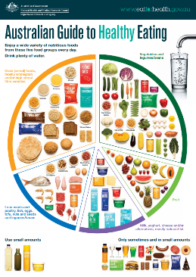

Sample 2:

Keeping lunchboxes real!
Lunchboxes don’t need to be difficult, nor do they have to look like a photo from a glossy magazine. They need to be achievable, affordable and give your kids healthy options that are full of energy to learn and play during the school day.
Try these top tips for making lunchboxes for your kids -
- Keep it simple.
- Think colour!
- Get kids involved.
- Small pieces for smaller hands.
- Keep it cool, keep it fresh.
- Look for the quick options.
For more information, take a look at:
- https://hw.qld.gov.au/blog/lunchboxes-keeping-it-real/
- https://www.healthier.qld.gov.au/healthy-families/eating-and-drinking-well/healthy-lunchboxes-made-easy/
- https://youtu.be/Pg98pAJ1AkE
Content provided by Health and Wellbeing Queensland www.hw.qld.gov.au
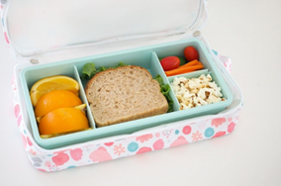

-------------------------------------------------------------------------------------------------------------------------------------------------------
Notes for schools:
- Lunchbox Week is held annually. Visit: https://www.healthylunchboxweek.org.au/ to find out the week for coming year so you can promote it at your school, and use resources developed by Nutrition Australia.

Sample 3:
Sneaky Sugars!
Are you on autopilot looking for quick snacks to fill up lunchboxes, reaching for snacks that you know the kids will eat? This is often the case from the middle of term – inspiration has dropped, and time limitations mean you grab an easy option from the cupboard.
Today we are putting the spotlight on Sneaky Sugars! This is looking at how much sugar there is in some of the popular quick lunchbox snack favourites. Even the snacks that claim to have fruit, and snacks we think are healthy, like muesli bars. How much sugar do you think there is in Apple Baked Fruit Bar? Maybe half a teaspoon per bar? Guess again. Each bar has 3 sneaky teaspoons of sugar!
Let’s have a look at some other popular lunchbox items.
The snack | How much sugar per snack | One snack every day of the school week
Fruit Strings | 2 teaspoons of sugar | 10 teaspoons of sugar
Roll Ups | 1 teaspoon of sugar | 5 teaspoons of sugar
Baked Twists | 3 and a half teaspoons of sugar | 16 and a half teaspoons of sugar
Tiny Teddies | 2 teaspoons of sugar | 10 teaspoons of sugar
Muesli Bars  Cherry Choc Chip and Yoghurt & Strawberry | 1 and a half teaspoons of sugar | 7 and a half teaspoons of sugar
LCMs | 2 teaspoons of sugar | 10 teaspoons of sugar
Milo Bars | 1 teaspoons of sugar | 5 teaspoons of sugar
Yogo | 8 teaspoons of sugar | 40 teaspoons of sugar

Here’s a challenge to try at home. Measure out the amount of sugar in some of your lunchbox foods. You’ll be surprised how much there is! Remember that 4 g of sugar = 1 teaspoon of sugar.
You can do this by looking at the Nutrition Information label on the packet of a snack and find the grams of sugar in each serve. Divide the grams by 4 and you will find out how many teaspoons of sugar are in each serve. How many Sneaky Sugars will you find?
For more information on sugar, check out:
- https://www.healthier.qld.gov.au/healthy-families/eating-and-drinking-well/sugary-drink-facts/
Content provided by Health and Wellbeing Queensland www.hw.qld.gov.au

Sample 4:
Snack Swapping!
We all need inspiration and tips to help plan our kids’ lunchboxes – and it can be a real challenge. So, what can you do?
- Plan before shopping for the week’s lunchboxes.
- List how many snacks you need and aim to swap processed snacks for healthier options that are lower in sugar and salt but still quick and easy.
- Slowly swap 1 or 2 a week before upping the amount over the term – as your kid adapts and learns to see new foods in their lunchbox.
- Buy in bulk to help keep costs down.
It takes time, and it may dip at times, but keeping some simple swaps gives them different tastes, colour and variety! Here are some swap ideas that can be prepared ahead.
SWAP THIS | FOR THAT
Muffins and cakes | Homemade Pikelets
Sweet Biscuits | Fruit Bread
Muesli bars/LCM bars | Corn thins with 100% fruit spread
Fruit straps & fruit bars | In season fruit such as mandarins
Chocolate dairy dessert | Homemade custard
Flavoured savoury biscuit | Pretzels
Chips | Air-popped popcorn
Processes cheese dip & biscuits | Dip and veggie sticks

For more information, visit:
- https://hw.qld.gov.au/blog/making-simple-food-swaps-for-your-family-with-9-ideas-to-get-you-started/

Content provided by Health and Wellbeing Queensland www.hw.qld.gov.au

Sample 5:

Boosting kids’ veggies and fruit intake
Most of us know veggies and fruit are important for our health and wellbeing and that Queensland children aren’t eating enough – particularly on the veggie front! Boosting kids’ intake of veggies and fruit can test parents – whether it’s picking out ‘green leaves’ or hiding it under cutlery. Here’s a few tips to help get more into our kids every day:
- Get them cooking – having children help in the kitchen makes them see, touch, smell and learn how foods need to be prepared for eating. This makes them want to eat their creations too – win win!
- Eat a rainbow – offering a variety of different colours means they will obtain a range of different nutrients, experience different tastes and flavours, and nudge them towards eating more every day.
- Encourage self-serving – placing several different veggies on a plate, kids can choose the amount and type of veggies they’ll aim to eat. It gives plenty of opportunity to talk through their choices, encourage variety and provides kids with confidence and decision-making skills.
- Be a lead – kids learn from what they see and hear. Parents need to set examples by including veggies on their plates too – with a diversity of colours, taste and flavours. Be encouraging and positive.
- Keep on offering – kids have more acute taste perceptions and need to learn about different tastes and flavours. This means it may take a few tries before they will accept a new flavour – so keep on offering. You may like to also try cooking veggies in different ways.
For information on what a serve of veggies is and how many children should consume, check out:
- https://www.eatforhealth.gov.au/food-essentials/five-food-groups/vegetables-and-legumes-beans
- https://hw.qld.gov.au/blog/eating-with-the-seasons-according-to-matt-golinski/
Content provided by Health and Wellbeing Queensland www.hw.qld.gov.au

Sample 6:

Getting label savvy
Your grocery shop is a great foundation to build a healthy eating pattern at home. Many of the foods we buy at our supermarket or store have a label – so what do these mean? Food labels can be confusing and tricky to understand, so here’s a quick summary of what you may find on labels:
- Nutrition Information Panel – offers the simplest and easiest way to choose foods in relation to fat, salt (sodium), sugars, kilojoules, and fibre. You can compare one product to another (using the nutritional information per 100 g) but also watch out on the serve size – these are chosen by the manufacturer!
- Health Star Rating – this front of pack labelling scheme provides convenient, relevant, and readily understood nutrition information and/or guidance on food packs to assist us to make informed food purchases and healthier eating choices. It provides an at-a-glance rating of the healthiness of the food product, as well as specific nutrient and energy information.
- Ingredient list – all ingredients in a food product must be listed on the label in order – from the largest to the smallest. This provides a practical way to see what the food contains the most of!
- Use-by and best-before dates – food with a shelf life of less than 2 years must have one of these labels, which mean different things. The use-by date on food labels outlines the date when the food should not be consumed after, for health and safety reasons (so they can’t be sold after that date). These foods usually are perishables like meat, fish and dairy products. Best-before dates refer to food quality – if food is stored in the recommended way the food will remain a good quality until that date. If the date passes the food may still be safe to consume but may have lost some quality and nutritional value.
For more information, see:
- https://www.health.qld.gov.au/news-events/news/understanding-food-labels
Content provided by Health and Wellbeing Queensland www.hw.qld.gov.au
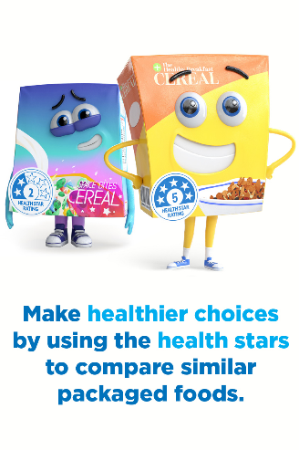

Sample 7:
Promoting positive food cultures outside of schools: tips for healthier eating out
You may have healthy lunchboxes covered, but what about when you go out as a family to eat? To help our kids cement the healthy habits they are learning in the classroom, it’s important they choose healthier options in all the places they spend time, such as when eating at cafes or restaurants or selecting from the canteen during weekend sport.
Typically, many foods available in cafés, restaurants or sporting canteens are deep fried or high in sugar and salt - which are not nutrients that help kids thrive. We also know most families are eating out of the home more, meaning kids are accessing these foods more often.
Try these tips and tricks that can help your family make healthier choices when spending time together away from home and school.
- Water is best – hydrating on water is so important, especially in sports settings. Alternatives to water include plain reduced fat milk or 100% fruit juice as opposed to soft drinks, sports drinks, milkshakes or cordials, which are high in sugar and can really ramp up the energy intake of kids.
- Make vegetables the focus, when choosing a main meal at venues. As your kids have been learning at school, veggies are packed with vitamins and minerals, and fibre. A healthier meal should contain at least 1 cup of salad or half a cup of cooked vegetables, either mixed into a sauce or casserole or served on the side.
- Look out for how food is cooked, and choose steamed, pan-fried, poached, baked, roasted or grilled over deep-fried foods. If it’s not on the menu, most venues would be happy to substitute for a healthier option.
- Avoid ordering a preferred meal choice just because it is in a meal deal or is promoted at the front of the store. You could see if there is an opportunity to substitute items, like swapping soft drink for water or the chips for salad?
- Research the venue before you go. Take a look at what sort of options they have available on their menu for families – is there something healthy you might be able to choose? If not, maybe it’s time to look for a new local.
Health and Wellbeing Queensland is supporting venues to commit to delivering healthier kids menus – check out the website: https://hw.qld.gov.au/healthy-kids-menu/.

Find more tips on healthier eating out: https://www.healthier.qld.gov.au/guide/healthy-eating-meals-out/.

Content provided by Health and Wellbeing Queensland www.hw.qld.gov.au
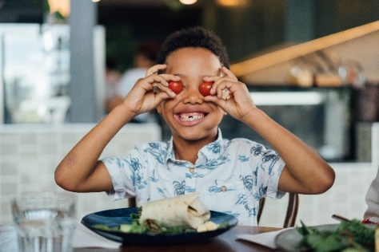

Sample 8:
Growing veggies, fruit and herbs with kids
Getting kids into the garden is a great way to build confidence and raise awareness of different tastes and flavours. Kids love seeing veggies and fruit growing into many different sizes, colours and at different speeds! Did you know gardeners are more likely to eat healthier diets?
If you don’t have a veggie patch at home already, you may wish to consider starting one at home.
- Get started, by trying to grow herbs – simply take some cuttings e.g. from rosemary or thyme, cut a steam about 10 cm to 15 cm from a plant and place the cut end in a container of water. Once you see roots on the cutting, you can plant it and continue watering. Hey presto – you’ve started a herb garden!
- You can grow seedlings in the small spaces such as herbs on the windowsill while other veggies such as carrots and tomatoes need more space so think garden beds or pots.
- Have you tried growing veggies from seeds like capsicums, tomatoes or pumpkins? Keep the seeds from your veggies and dry them out before planting in a small container of soil, making sure you water regularly. Once they start sprouting, transfer them to a larger pot (well-spaced out) and continue to water.
By being aware of what you put in your garden, choosing the right plant for the local climate and environment, making it simple and getting the kids involved, you will start reaping the rewards.
For more information and help, take a look at:
- https://www.healthier.qld.gov.au/guide/hints-and-tips/
Content provided by Health and Wellbeing Queensland www.hw.qld.gov.au
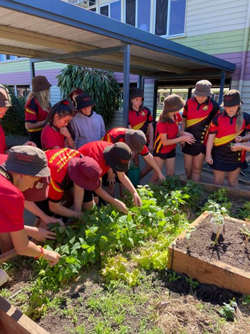

Sample 9:
Into the kitchen!
Cooking with kids is great at involving their listening skills, touching, looking, smelling and finally tasting the end product. By having them cook meals or snacks, they will see what goes into food and how to make a dish or snack a healthier option.
There are thousands of recipes available online or in the supermarket magazines you may pick up while out shopping. So, start simple and involve them in choosing which dish they want to cook. They will also learn maths skills – think measuring or counting; and they will learn language – how to read the recipe and how to follow instructions. But one of the best assets may be the fact they can prepare and cook for themselves (or you!) in later years.
So where do you start? Some kids love starting when they are little and at preschool age – so select appropriate jobs for them to help you, and slowly progress onto jobs that are safe. Progress from homemade dips, making healthy muffins or making sandwiches for their lunchboxes, onto making a smoothie, pancakes or soup.
Remember the main thing is to keep safe.
Top tips:
- Be safe (and clean)
- Plan and pick age-appropriate tasks
- Give yourself extra time
- Guide your child through the recipe
- Give your child independence and choice – but supervise!
For more recipes, check out:
- https://hw.qld.gov.au/blog/boost-your-recipes/
- https://www.qcwacountrykitchens.com.au/recipes/
You could also sign up to online cooking classes with Jamie’s Ministry of Food or look at your local council for school holiday programs.
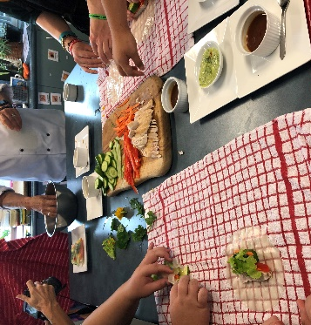
Content provided by Health and Wellbeing Queensland www.hw.qld.gov.au

Sample 10:
Why do growing children need veggies and fruit?
It is important that we encourage children to eat more veggies and fruit every day – for growth and development and to support learning in class, as well as to form lifelong healthy habits.
We know veggies are fruit good for us, but why? Let’s look at why you should eat them:
- Loaded with vitamins and minerals – like vitamin C, potassium, folate. Did you know the more colours your kids eat, the more varieties of vitamins and minerals they will get?
- Packed with fibre - can help maintain a healthy gut and prevent constipation and other digestive problems. Fibre makes you feel fuller and more satisfied too.
- Boost your water intake – we all know water is vital for our bodies. Some veggies and fruit are higher than others – who likes watermelon on a hot day?
- Adds variety to your food – giving colour, diversity, and variation. Orange, red and yellow fruit contain carotenes (Vitamin A) – which are thought to be great at boosting our immunity.
- Reduces long term risk of diseases such as heart disease, stroke, and some cancers.
- Tasty and delicious – adding plenty of flavour into dishes or onto the plate.
- Available all year round – choosing seasonal veggies and fruit will help the budget.
- Low in nutrients we need to limit, such as salt, fat and added sugar.
A common error we all make is around calculating the size of a serve of veggie or fruit. Having 5 peas and a few slices of carrot on the plate doesn’t count as 2 serves (due to 2 different colours!).
Fruit is easier to estimate as most are in natural sizes for eating – think apple, banana, pear – but others are harder. Here’s some examples of veggies for you:
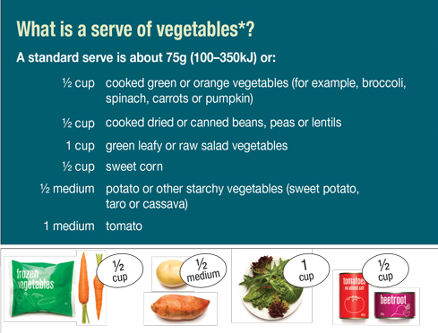

So give your children a veggie or fruit boost and nudge them in the right direction by increasing what they are eating! For some fun ways, take a look at: https://www.healthier.qld.gov.au/healthy-families/eating-and-drinking-well/pretty-plates/
Content provided by Health and Wellbeing Queensland www.hw.qld.gov.au

Sample 11:
Keep food safe
Teaching kids about food safety is so important. This may involve ensuring good handwashing routines before or during cooking and eating; how to handle or store food at home or at school or looking at the ‘best before’ or ‘use by’ dates.
Wash hands
- Before cooking
- After handling food
- After using the toilet
- Blowing your nose
Read the labels
- ‘Best Before dates’ and ‘Use by dates’
- Ingredient’s list
- Storage information – in the fridge or freezer, don’t refreeze, once open keep for the recommended duration
Stacking the fridge
- Storing veggies and fruit in the crisper will keep them fresher for longer
- Store raw meat, seafood and poultry on the bottom shelf of the fridge
- Don’t defrost frozen produce on the kitchen surface or in the kitchen sink!
Lunchbox safety
- Keep to lower risk options, such as well-cooked meats, hard cheese, well-washed fruit and veggies, vegemite
- Use freezer packs or frozen small water bottles to keep things chilled
- Discard any uneaten foods/ leftovers
Learn more:
- https://www.healthier.qld.gov.au/healthy-families/eating-and-drinking-well/food-safety/
- https://www.betterhealth.vic.gov.au/health/healthyliving/food-safety-when-cooking
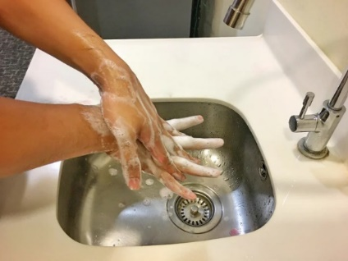
Content provided by Health and Wellbeing Queensland www.hw.qld.gov.au

Sample 12:
Making smart food choices at school and at home.
Did you know there is a Queensland guide that supports schools to ensure healthy food and drinks are supplied and promoted in schools?
The Smart Choices – Healthy Food and Drink Supply Strategy for Queensland schools covers all school activities and situations where food and drink may be supplied or promoted – from tuckshops to school events, from classroom rewards to fundraising. This aligns with the Australian Dietary Guidelines and helps ensure children have healthier food and drink options while at school.
But what about at home? Are you confused about how to put into practice all the healthy eating advice you hear about, read and see? How can different food and drink preferences and needs of your children and family members be managed?
Try these tips to establish routines and behaviours that can help you and your children develop healthy eating behaviours:
- Connect during mealtimes or when eating – turn off the TV or put the phone away
- Try parent provides, child decides’ mealtimes
- Create a positive atmosphere
- Get kids involved in the preparation and serving food
- Be a role model
- Get organised – plan and be prepared for the week’s food requirements
- Eat together – whether with family, friends, peers or work colleagues
- Try variety and diversity, with new flavours and tastes

For more tips and advice – see:
- https://healthy-kids.com.au/parents/developing-positive-eating-behaviours/
- https://www.healthier.qld.gov.au/guide/7-dinnertime-habits-to-improve-your-childs-health/
Content provided by Health and Wellbeing Queensland www.hw.qld.gov.au

Recipes
Recipe 1: Roasted Vegetable Frittata
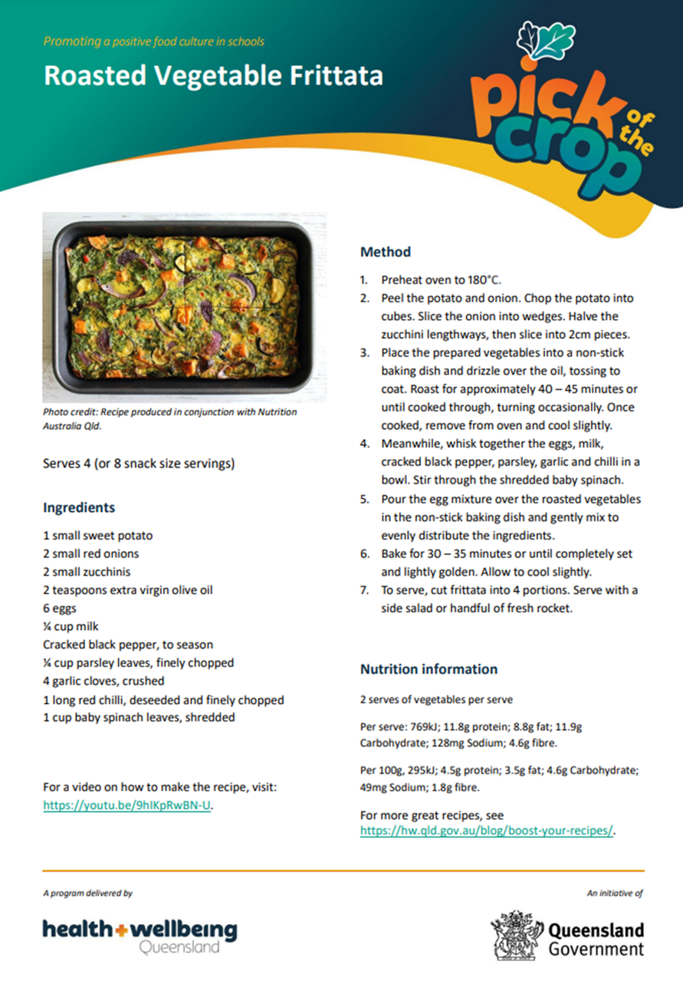

Recipe 2: Matt Golinski’s Rice Paper Rolls
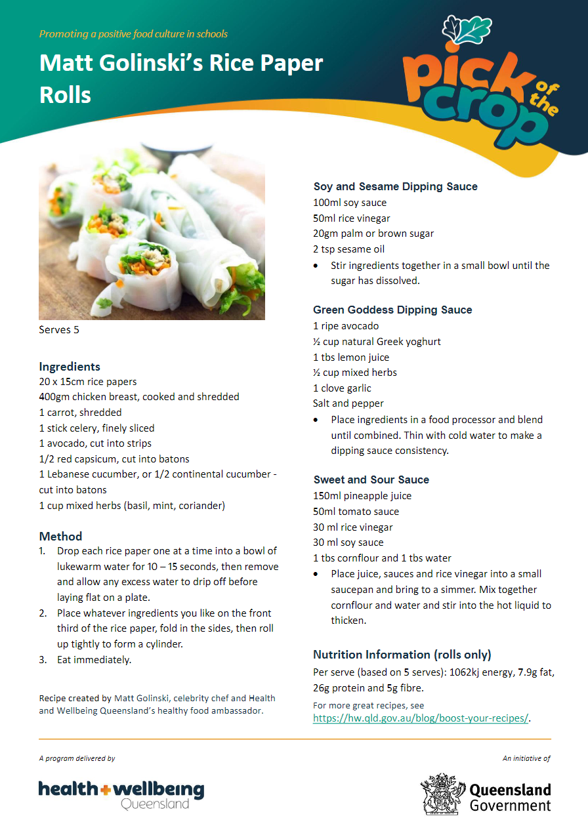

Recipe 3: Mango, Avocado and Macadamia Salad
