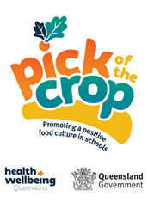
Please adapt and use the following newsletter articles if your school is participating Pick of the Crop. Highlighted text indicates where local information can be inserted.
They provide you with the opportunity to connect with families, parents and carers and inform them of activities and initiatives being implemented as part of the Pick of the Crop in your school.
Additional newsletter articles on food and nutrition topics can also be found at: www.hw.qld.gov.au/pick-of-the-crop.

Article 1 - Introduction to Pick of the Crop – for 2022
[name] State School embraces Pick of the Crop.
This year, [name] State School is so pleased to be participating in the Pick of the Crop program, funded by Health and Wellbeing Queensland. [add more information if your school has been participating in the program in 2021].
We have been working with [name], our Pick of the Crop regional coordinator, to boost actions that will encourage our students to learn about, see, taste and try veggies and fruit during the school day. We were successful in securing funding from Health and Wellbeing Queensland to help us achieve our goals, and we encourage you all to help our students become veggie kids!
Plans ahead for 2022 include [insert school plans and ideas]
This whole school healthy eating program has been running in 2021 in Bowen, Bundaberg and Logan and we are so keen to be involved as it links the students teaching and learning in the classroom with activities across the whole school.
Most of us know that kids (and us!) are not eating enough veggies and fruit every day. By increasing our intake by even one extra serve, we can all gain benefits to our health in the long term.
We look forward to sharing lots of exciting and interesting stories with you this year from our participation in Pick of the Crop.
For more information on Pick of the Crop, visit: https://hw.qld.gov.au/pick-of-the-crop/
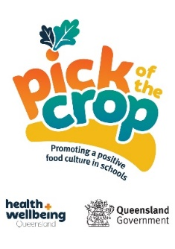
Suggest using the image:

Article 2 - Progress of Pick of the Crop within your school
Great Actions for Pick of the Crop
You may have been hearing all about Pick of the Crop from your kids at home or seen posters and signs around the school.
Pick of the Crop is all about veggies and fruit. The program aims to embed healthy eating messaging in different and interesting ways across our school. This may include building a school garden, visiting a local farm or producers, or just giving students the opportunity to try and taste veggies and fruit during the day.
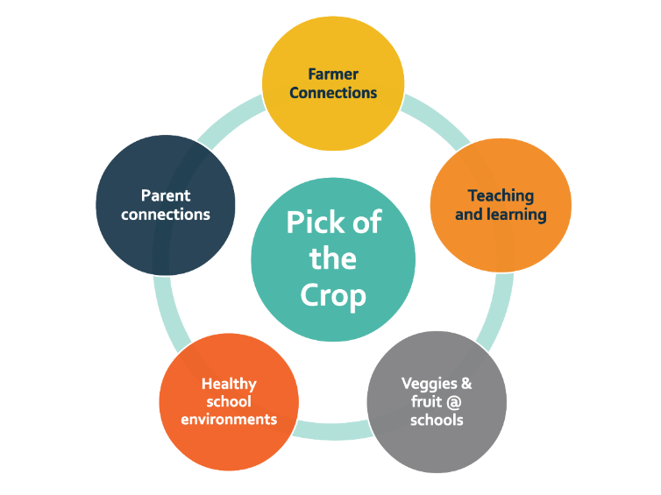
There are five components that encompass Pick of the Crop and these are:

We have received funding from Health and Wellbeing Queensland and are focusing primarily on [insert action or activity] and [insert action or activity]. However, we are really keen that students also can put their learnings into practice across their whole lives – and that includes the time they are outside the school.
You will have seen articles in our [newsletters/communications] that are designed to help families, parents and carers gain more insight into how we can ensure our kids grow and develop into healthy adults, across all parts of their lives. Why not help connect home life with what is happening in school?
Pick of the Crop is helping our school really consider the whole child and set up healthy habits for now but also into the future. So let’s work together to get healthy happening.
For more information, see www.hw.qld.gov.au/pick-of-the-crop

